Selenium

Originally, Selenium was created as a tool to automate web browsers. It then evolved into a framework meant for running tests in various browsers and multiple operating systems. This includes combinations like Chrome and Firefox, or Windows and Linux. To create a program that could run across many browser and operating system setups, the Selenium team developed three separate components instead of a single macro.
The first is Selenium IDE (Integrated Development Environment), which is a recording tool that allows testers to record their own Selenium tests. The second is Selenium WebDriver, a programming library that enables developers to write automated tests and interact directly with the web browsers they use while building a website. The third is Selenium Grid, an execution tool that helps testers run their automated tests across different browser and operating system combinations by sending the tests to multiple machines and browsers at once. By using these three components of Selenium, you can design and create automated software testing scripts, run your tests, and store everything on your computer.
Although Selenium offers many benefits, it also has certain limitations. It does not provide built-in support for testing desktop or mobile applications, and it lacks native reporting features. Additionally, creating and maintaining Selenium test scripts requires programming skills and can be challenging for complex applications. However, these challenges can be addressed by combining Selenium with other tools and frameworks.
Overall, Selenium plays a vital role in ensuring the quality and reliability of web applications. Its open-source nature, wide browser compatibility, language flexibility, and strong community support make it one of the most widely used automation testing tools in the software industry today. As web technologies continue to evolve, Selenium remains a reliable solution for automated web testing.

Test case

Q1. Write a Test case for a program which add two numbers.
Test ID: TC_ADD_001
Test Case Description:
Verify that the program correctly adds two valid numbers and displays the correct result.
Pre-Conditions:
- Size of the integer is must be of 2 digits.
- Digits has to be in Integers.
- Third value of has to be greater then the previous value.
Test Steps:
- Enter value a = 10;
- Enter value b = 20;
- Click add
Expected Result:
- 40 (>10,20)
Actual Result:
- 30
Pass / Fail Status:
- Pass
Comments:
- Addition functionality is working as expected for valid numeric inputs.

Q2. Take 3 integers and find out the greatest one
Source code:
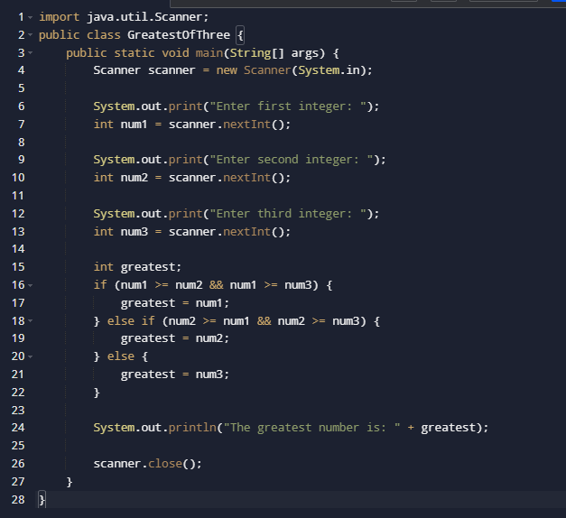
Test ID: TC_Great_002
Test Case Description:
Verify that the program correctly identifies the greatest number when all three inputs are distinct positive integers.
Pre-Conditions:
- The number has to be in range.
- Digits has to be in Integers.
S.no | Test Step | Expected Result | Actual Result | Pass or Fail
1. | Enter Value= 10  Enter Value= 20  Enter Value= 30; | 30 | 30 | Pass
2. | Enter Value= 10  Enter Value= 20  Enter Value= abc; | 30 | Exception in thread "main" java.util.InputMismatchException | Fail
3. | Enter Value= 10  Enter Value= 12.50  Enter Value= 20; | 30 | Program crashes due to invalid input | Fail

Comments:
- Program correctly handles ties by selecting one of the greatest value.

Q3. Input a name and print it the number of time user wishes to display (counter, for loop, while loop and do while loop).
Source code:

Test ID: TC_Name_003
Test Case Description:
all the three case .
Pre-Conditions:
- The number has to be in range.
- User has access to input console.
- System is functioning properly.
Test Step:
- Run the program.
- Enter name as “Krishna”.
- Enter number as “3”.
- Observe the output.
Expected Result:
The name “Krishna” should display 3 times.
Actual Result:
Krishna displayed 3 times.
Pass/Fail Status:
Pass
Comments:
Counter loop works correctly.

